App Dev Project Report

Student Details
Name: Nikunj Bajoria
Roll Number: 25F2000436
Email: 25f2000436@ds.study.iitm.ac.in
About Me: I am an undergraduate B.S. Data Science student at IIT Madras with a strong interest in software development. I enjoy frontend development and building systems that solve practical problems. This project helped me gain experience in backend development, database design and building web applications.

2. Project Details

Project Title: Placement Portal Application

Problem Statement:
You are required to build a Placement Portal Application web application that allows Admin (Institute), Company, and students to interact with the system based on their roles.

Approach:
The application was developed using Flask as the backend framework with a modular structure. The system follows a role-based architecture consisting of three user roles:
Admin
- Approves company registrations
- Manages placement drives
- Monitors students, companies, and applications

Company
- Registers and creates company profile
- Creates placement drives
- Views student applications

Student
- Registers and creates student profile
- Views approved placement drives
- Applies for placement drives
- Tracks application status

The backend manages all application logic and database operations using SQLAlchemy ORM. The frontend is designed using HTML templates rendered through Jinja2 for responsiveness and usability.

3. AI/LLM Declaration
I used ChatGPT (GPT-5) to assist in writing SQLAlchemy model definitions, generating HTML template structures, and debugging Flask routes and database issues.
The extent of AI/LLM usage is around 15-20%, limited to code suggestions and documentation formatting.
All major implementation logic, debugging, and integration were done manually.

4. Technologies and Frameworks Used
Technology / Library | Purpose
Flask | Backend web framework for handling routes and application logic.
SQLAlchemy | Object Relational Mapper for SQLite database
Jinja2 | Template engine used to generate dynamic HTML pages
Bootstrap 5 | Frontend styling and responsive design
HTML/CSS | Structure and styling of the user interface
SQLite | Lightweight database used for storing application data

5. Database Schema / ER Diagram
Tables:
Admin
Stores administrator credentials used to manage the system.
Fields:
- Id
- Username
- Password

Student
Stores student profile information.
Fields:
- Id
- Name
- Email
- Password
- Phone
- Branch
- CGPA

Company
Stores company profile details.
Fields:
- Id
- Name
- Email
- Password
- HR_Contact
- Website
- Approval_status

PlacementDrive
Stores job postings created by companies.
Fields:
- Id
- Job_Title
- Job_Description
- Eligibility
- Deadline
- Status

Application
Stores student applications for placement drives.
Fields:
- Id
- Student_id
- Drive_id
- Status

Relationships:
One-to-ManyRelationships
Student → Application (A student can apply to multiple placement drives.)
PlacementDrive → Application (Each placement drive can receive multiple student applications.)
Company → PlacementDrive (A company can create multiple placement drives.)

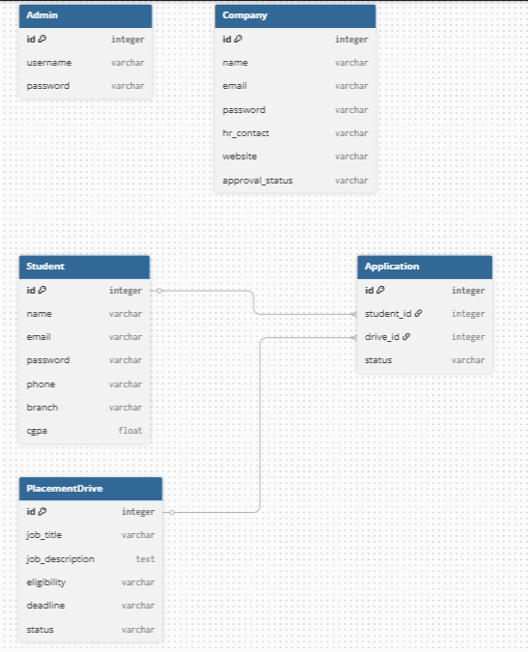

7. Architecture and Features

Implemented Features:

Core features implemented in the application include:

- Role-based login system
- Student registration and profile management
- Company registration
- Placement drive creation by companies
- Viewing available placement drives by students
- Applying for placement drives

